**Team member:**

**Kyle Jia, jj3708**

**Junxiao Wang, jw8193**

**Nikhil Diddee, nd2564**

**Milestone 3: Database Setup and SQL**

**1. Database Server**

We are hosting our database on phpMyAdmin running locally. The database name is slime_runner_db and it contains all 10 tables required for our Slime Runner endless runner game project.

**2. Database Tables and Sample Data**

This section demonstrates that all required tables have been successfully created and populated with sufficient realistic data.

**2.1 Player Table**

The player table stores information about both registered users and guest players. It contains 10 rows with usernames, emails, passwords, account types, and timestamps. Registered players have email and password while guest accounts have NULL values for these fields.

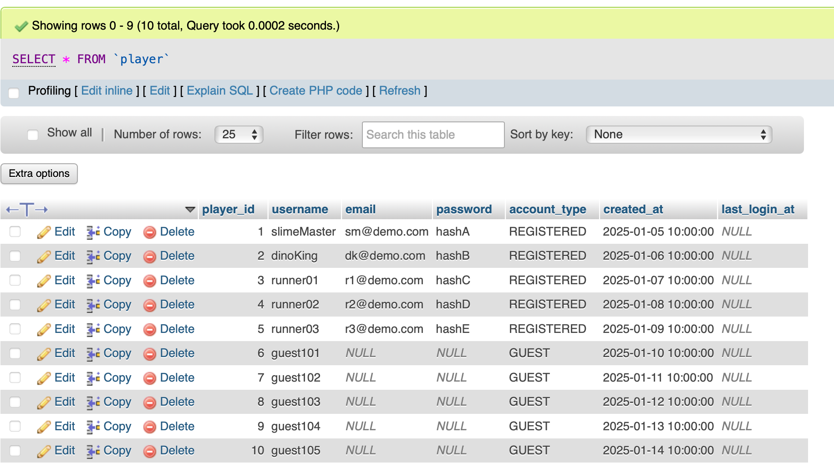

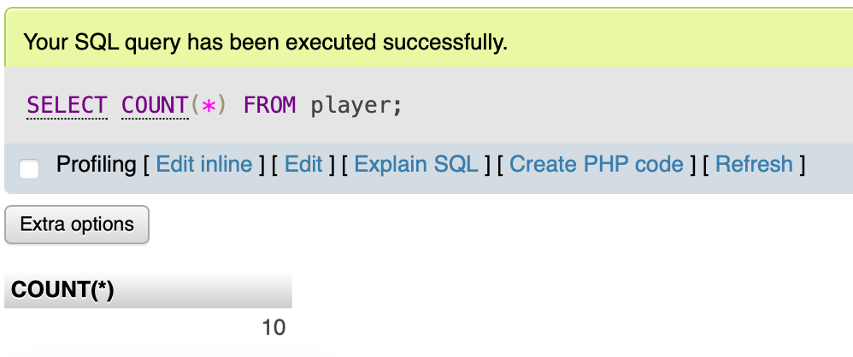

**2.2 Season Table**

The season table tracks different competition periods spanning January to October 2025. It contains 10 rows with season names, start dates, end dates, and an is_active flag indicating Season 10 is currently active.

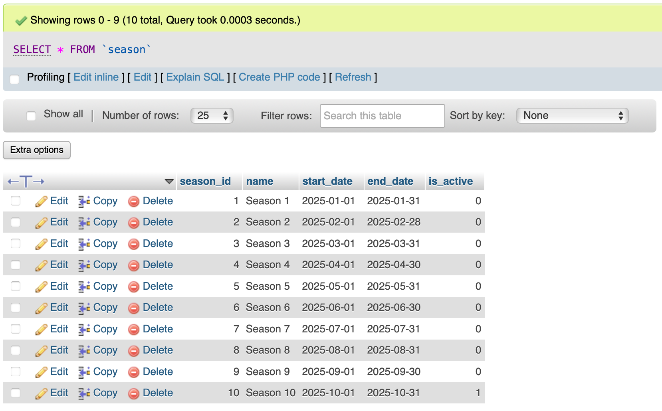

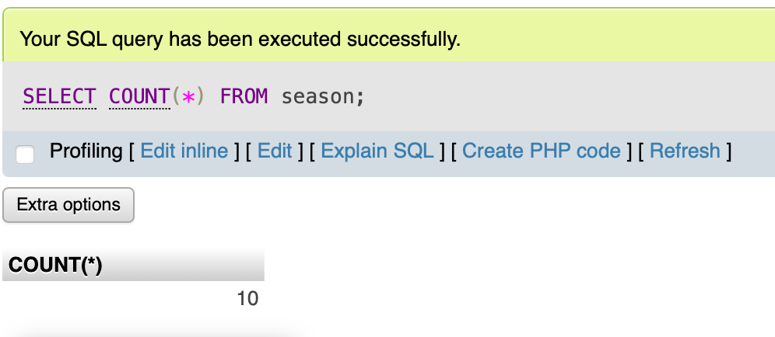

**2.3 Skin Table**

The skin table contains 10 different character skins with varying rarity levels from common to legendary. The Classic skin is marked as the default skin that all players own automatically.

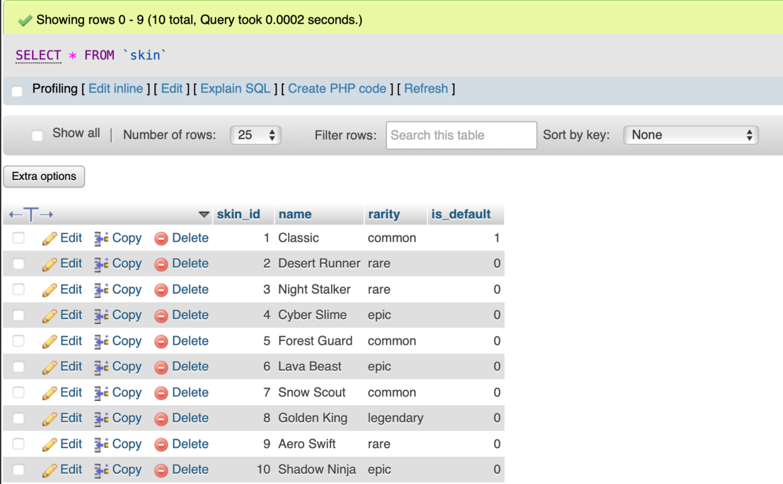

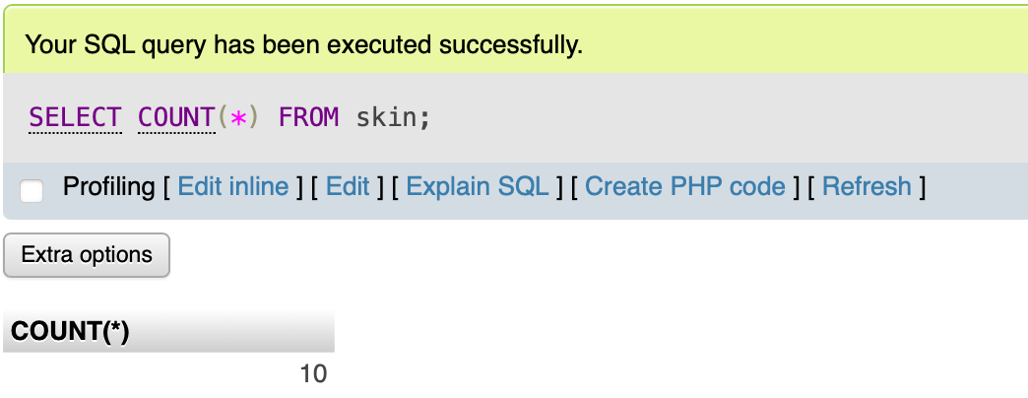

**2.4 PlayerSkin Table**

The player_skin table contains 15 rows tracking which skins each player owns and how they acquired them. All players own the default skin and some have acquired additional skins through achievements or purchases.

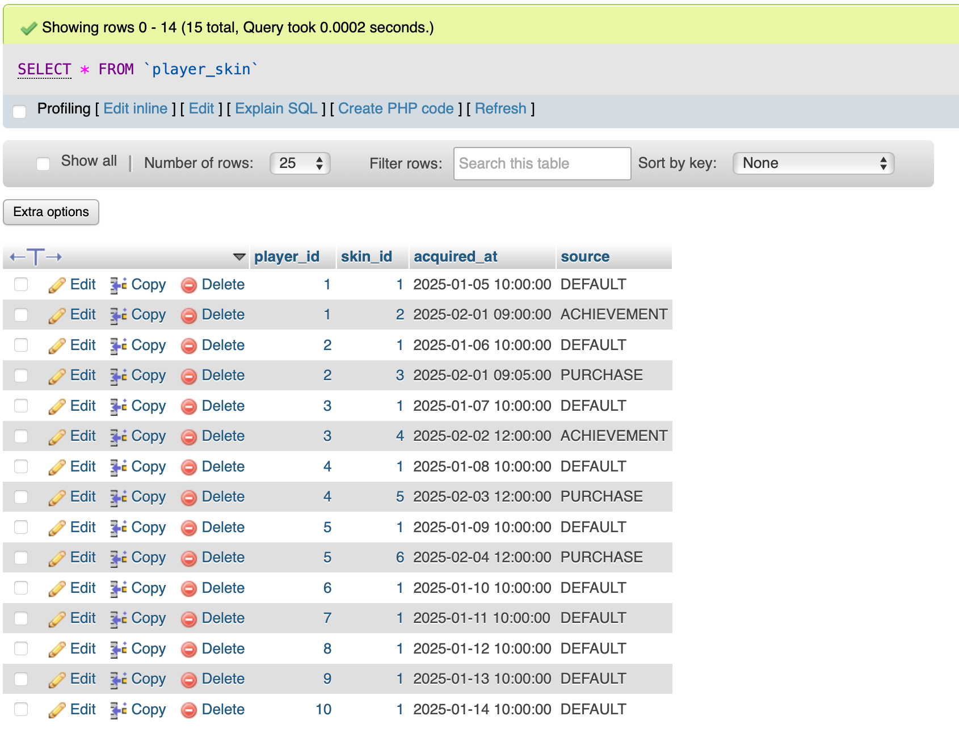

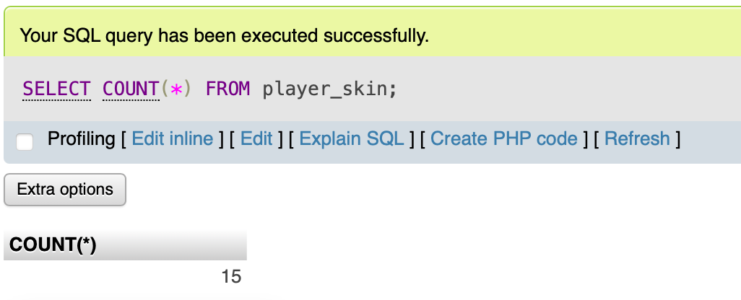

**2.5 Session Table**

The session table contains 10 gameplay sessions with realistic score and distance data from Season 3. Each session includes player ID, season ID, skin used, timestamps, scores, distances, top speeds, and crash types. The duration_ms field is automatically calculated.

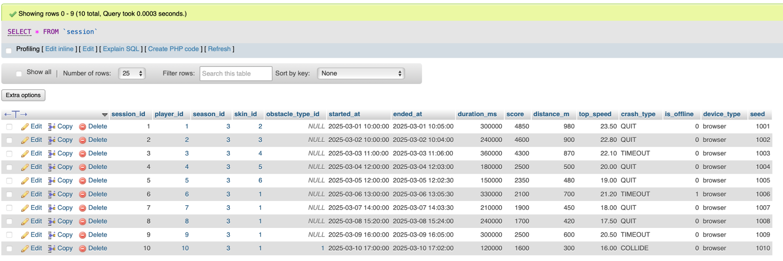

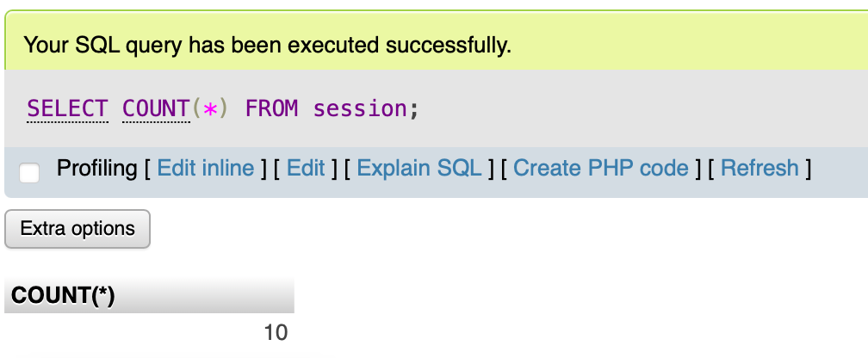

**2.6 ObstacleType Table**

The obstacle_type table defines 10 different obstacles with varying sizes and altitudes. Some are ground obstacles like cacti and rocks while others are air obstacles like birds and drones. Each has width and height dimensions in pixels.

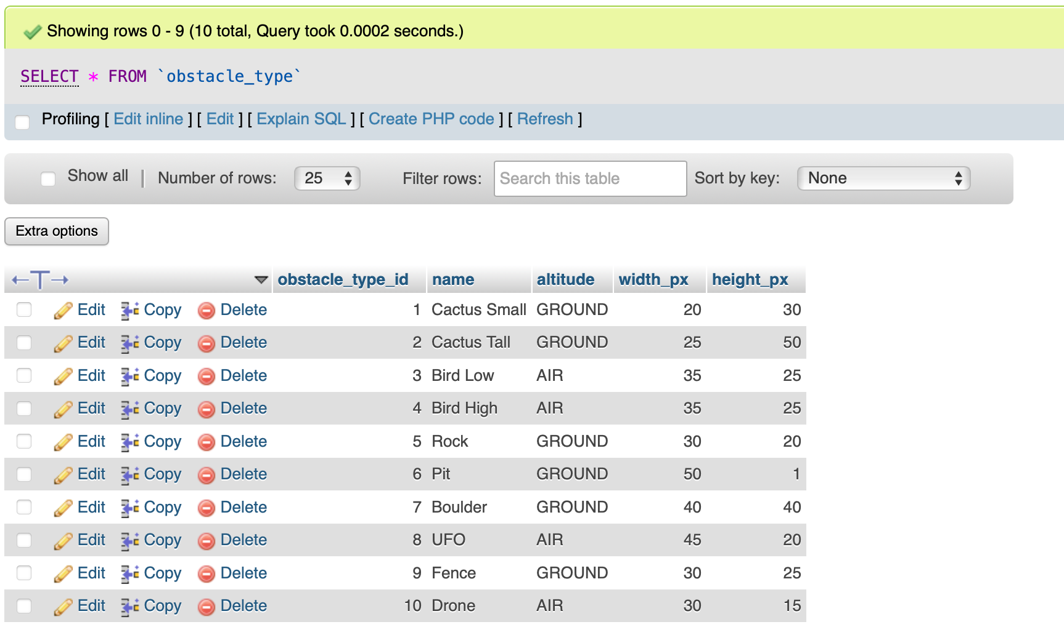

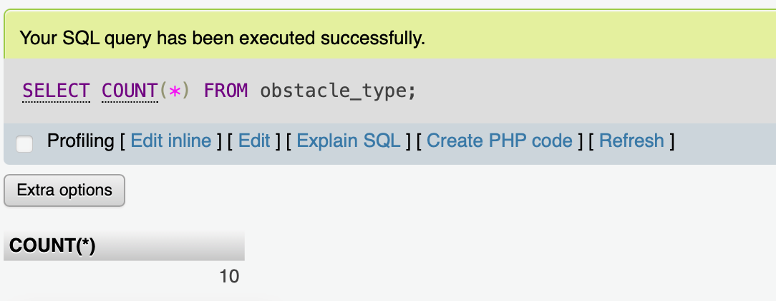

**2.7 ObstacleSpawn Table**

The obstacle_spawn table contains 10 rows recording when obstacles appeared during gameplay sessions. Each entry includes timing offsets, spawn speeds, and whether the obstacle was cleared. Most obstacles were cleared except one that caused a collision.

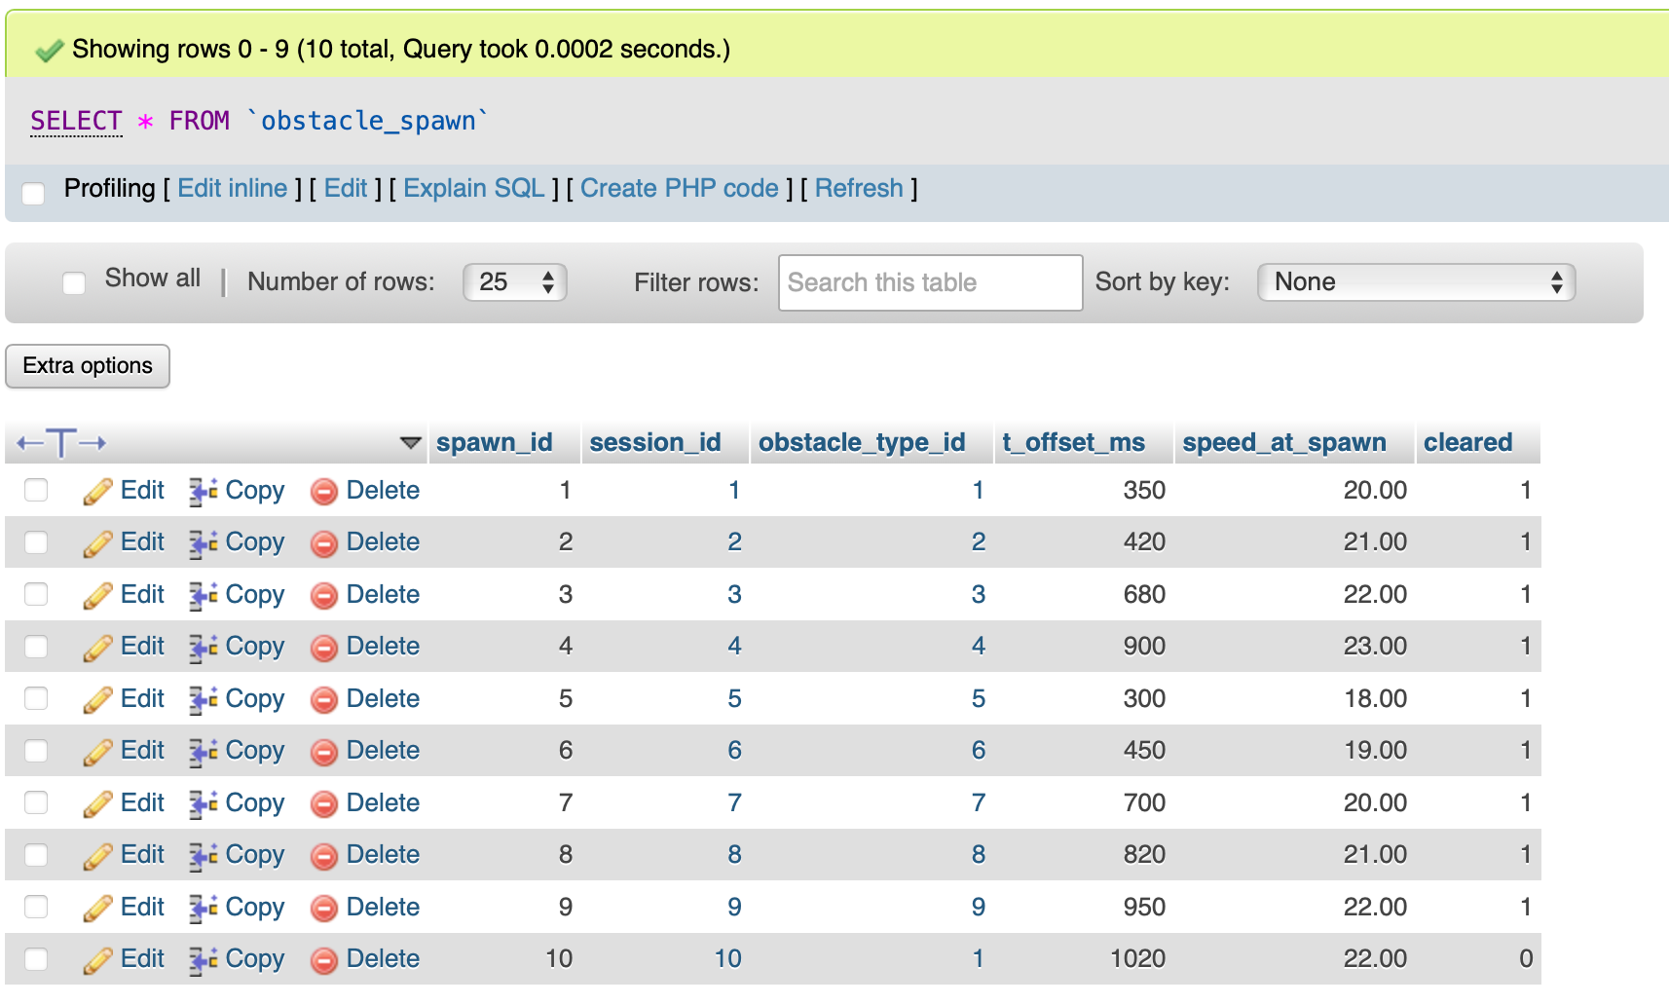

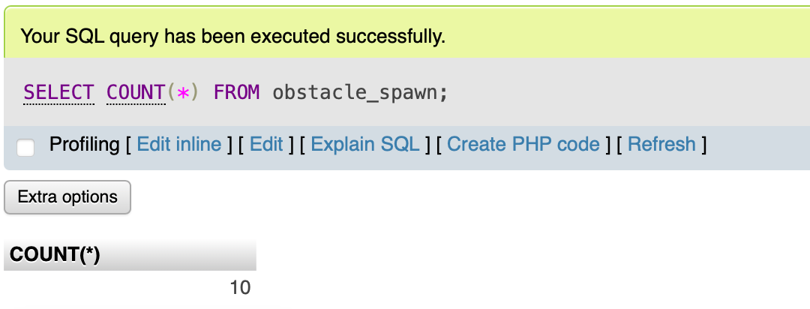

**2.8 InputEvent Table**

The input_event table captures 10 player actions with precise timing information. Actions include jumps, ducks, pauses, and resumes with their time offsets and input sources like keyboard or touch.

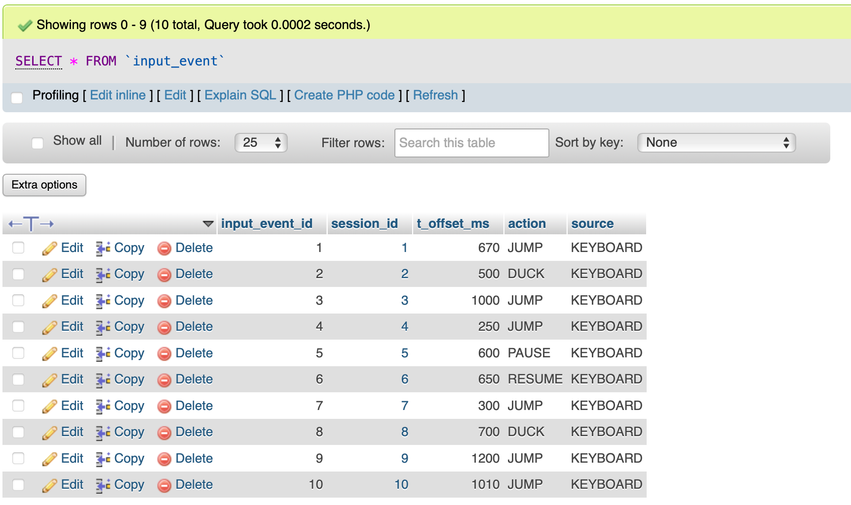

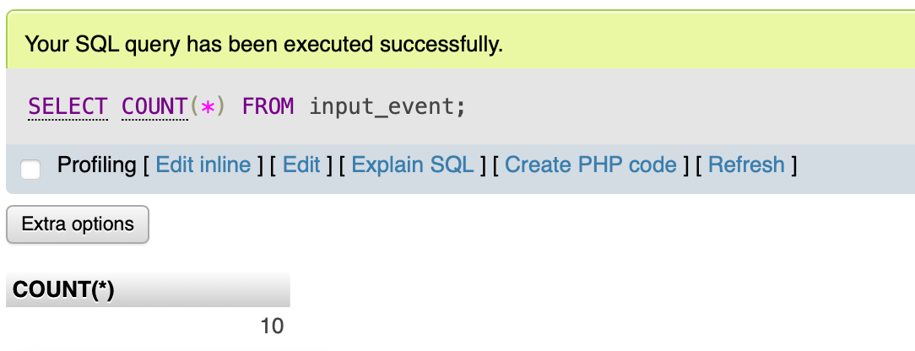

**2.9 Achievement Table**

The achievement table defines 10 unlockable achievements with varying difficulty levels. These include distance milestones, speed challenges, collection goals, and gameplay requirements.

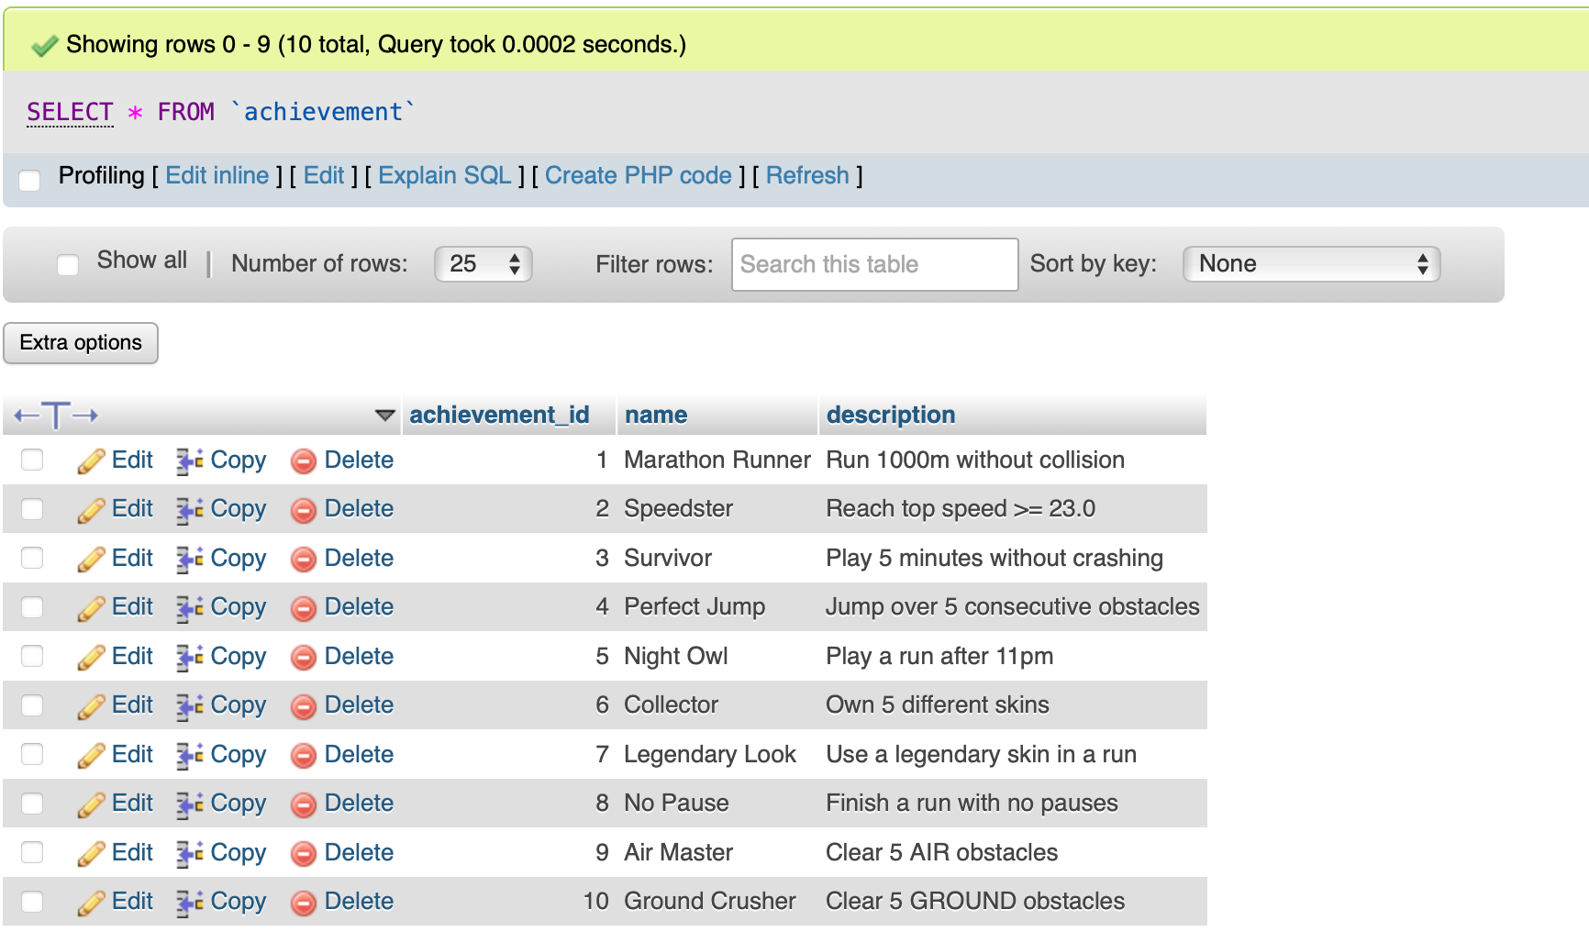

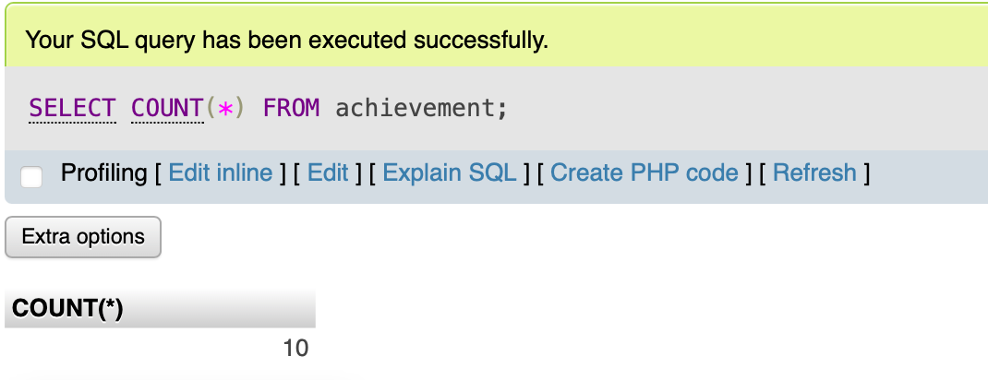

**2.10 PlayerAchievement Table**

The player_achievement table contains 10 rows showing which achievements players have unlocked. Each entry links to the specific player, achievement, session where it was earned, and timestamp.

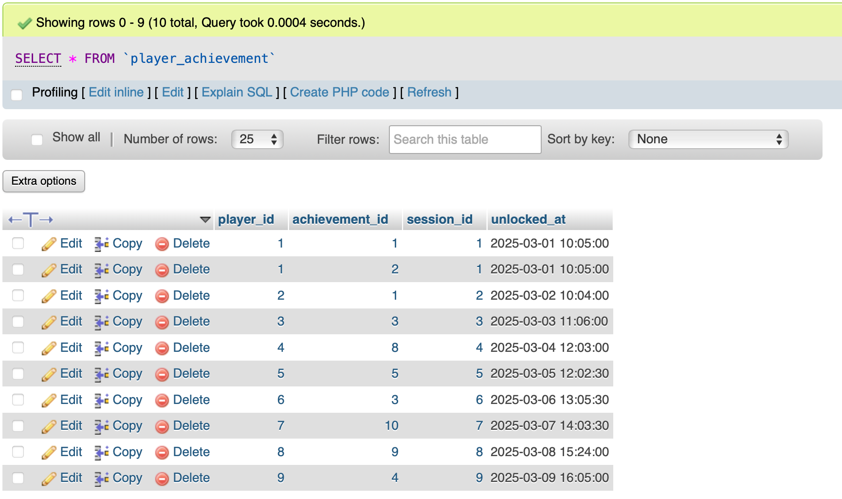

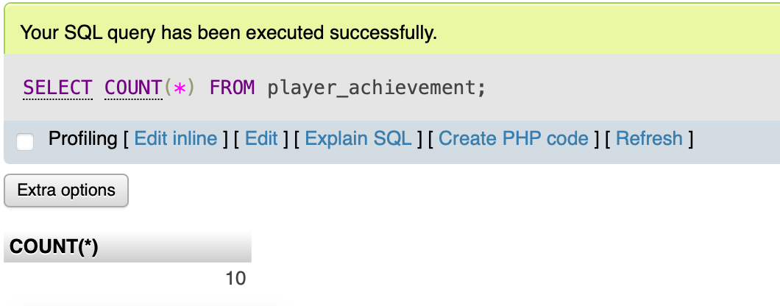

**3. SQL Commands Used in Our Application**

This section documents all SQL commands that our application uses to interact with the database.

**3.1 Non-Advanced SQL Commands**

**Create Commands**

All 10 tables were created using CREATE TABLE statements with appropriate data types, primary keys, foreign keys, and constraints. The complete statements are in COMMANDS.sql.

**Insert Commands**

We populated each table with realistic sample data. Examples include:

INSERT INTO player (username, email, password, account_type, created_at) VALUES ('slimeMaster','sm@demo.com','hashA','REGISTERED','2025-01-05 10:00:00');

INSERT INTO season (name, start_date, end_date, is_active) VALUES ('Season 1','2025-01-01','2025-01-31',0);

INSERT INTO skin (name, rarity, is_default) VALUES ('Classic', 'common', 1);

All INSERT statements are included in COMMANDS.sql.

**Select Commands**

Our application uses various SELECT queries:

Get all registered players:  
SELECT * FROM player WHERE account_type = 'REGISTERED';

Get leaderboard for a specific season:  
SELECT p.username, s.score, s.distance_m, s.top_speed FROM session s JOIN player p ON s.player_id = p.player_id WHERE s.season_id = 3 ORDER BY s.score DESC LIMIT 10;

Get achievements for a player:  
SELECT a.name, a.description, pa.unlocked_at FROM player_achievement pa JOIN achievement a ON pa.achievement_id = a.achievement_id WHERE pa.player_id = 1;

Get skins owned by a player:  
SELECT s.name, s.rarity, ps.acquired_at, ps.source FROM player_skin ps JOIN skin s ON ps.skin_id = s.skin_id WHERE ps.player_id = 1;

Get active season:  
SELECT * FROM season WHERE is_active = 1;

Get session history:  
SELECT session_id, score, distance_m, started_at, crash_type FROM session WHERE player_id = 1 ORDER BY started_at DESC;

**Update Commands**

Update player last login:  
UPDATE player SET last_login_at = NOW() WHERE player_id = 1;

Update session score:  
UPDATE session

SET ended_at = NOW(),

score = 5000,

distance_m = 1000,

top_speed = 25.5,

crash_type = 'COLLIDE',

obstacle_type_id = 1 -- keep crash info consistent

WHERE session_id = 1;

Activate new season:  
UPDATE season SET is_active = 0 WHERE is_active = 1;  
UPDATE season SET is_active = 1 WHERE season_id = 10;

**Delete Commands**

Delete guest player:  
DELETE FROM player WHERE player_id = 10 AND account_type = 'GUEST';

Delete old sessions:  
DELETE FROM session s

WHERE s.season_id < 3

AND NOT EXISTS (

SELECT 1

FROM player_achievement pa

WHERE pa.session_id = s.session_id

);

**3.2 Advanced PL/SQL Commands**

**Advanced Feature 1: STORED PROCEDURE**

Purpose: Validates that crash data in a session is consistent with the obstacle spawn records.

Parameters:

p_session_id (INT): The session ID to validate

Returns: None (raises an error if validation fails)

Business Logic: This procedure enforces complex validation rules for session crashes. If a session crashed due to collision (COLLIDE), there must be exactly one uncleared obstacle spawn and the obstacle_type_id must match between the session and the uncleared spawn. For non-collision crashes (QUIT or TIMEOUT), all obstacle spawns must be marked as cleared. This ensures data consistency between the session and obstacle_spawn tables.

-- USE dino_runner;

DELIMITER //

CREATE PROCEDURE sp_validate_session_crash(IN p_session_id INT)

BEGIN

DECLARE v_crash VARCHAR(10); DECLARE v_obst INT; DECLARE v_uncleared INT; DECLARE v_match INT;

SELECT crash_type, obstacle_type_id INTO v_crash, v_obst FROM session WHERE session_id = p_session_id;

IF v_crash IS NULL THEN SIGNAL SQLSTATE '45000' SET MESSAGE_TEXT = 'Session not found'; END IF;

IF v_crash = 'COLLIDE' THEN

SELECT SUM(CASE WHEN cleared = 0 THEN 1 ELSE 0 END) INTO v_uncleared FROM obstacle_spawn WHERE session_id = p_session_id;

IF v_uncleared <> 1 THEN SIGNAL SQLSTATE '45000' SET MESSAGE_TEXT = 'COLLIDE must have exactly one uncleared spawn'; END IF;

SELECT COUNT(*) INTO v_match FROM obstacle_spawn WHERE session_id = p_session_id AND cleared = 0 AND obstacle_type_id = v_obst;

IF v_match <> 1 THEN SIGNAL SQLSTATE '45000' SET MESSAGE_TEXT = 'Crash obstacle_type_id mismatch'; END IF;

ELSE

SELECT SUM(CASE WHEN cleared = 0 THEN 1 ELSE 0 END) INTO v_uncleared FROM obstacle_spawn WHERE session_id = p_session_id;

IF v_uncleared <> 0 THEN SIGNAL SQLSTATE '45000' SET MESSAGE_TEXT = 'Non-collide session cannot contain uncleared spawns'; END IF;

END IF;

END//

DELIMITER ;

Procedure Testing:

Test 1: CALL sp_validate_session_crash(10);

Result: Success because session 10 has crash_type COLLIDE with exactly one uncleared obstacle spawn and matching obstacle_type_id

Test 2: CALL sp_validate_session_crash(1);

Result: Success because session 1 has crash_type QUIT with all obstacle spawns cleared

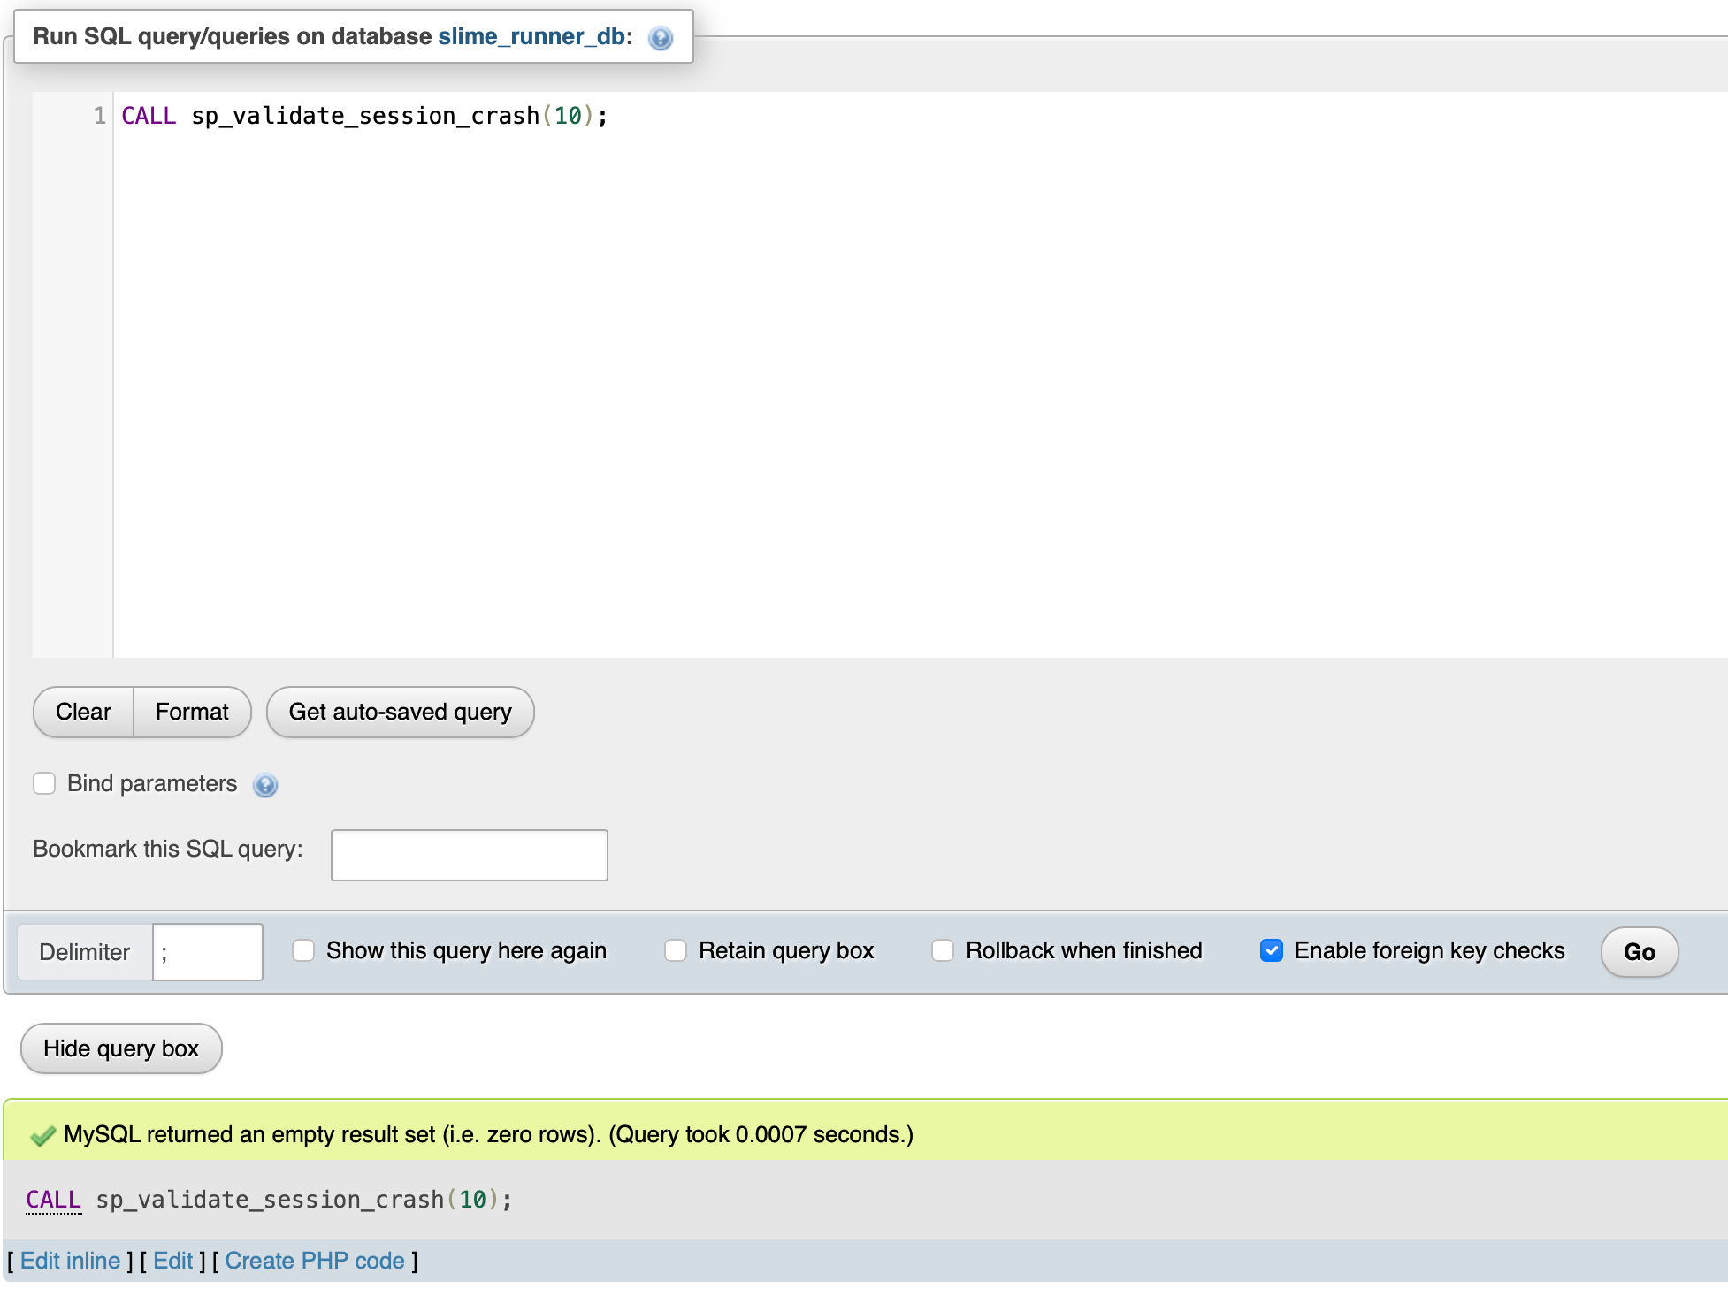

**Advanced Feature 2: FUNCTION**

**fn_player_owns_skin Function**

Purpose: Checks whether a player owns a specific skin at a given point in time.

Parameters:  
p_player_id (INT): The player ID to check  
p_skin_id (INT): The skin ID to verify  
p_at (DATETIME): The timestamp to check ownership

Returns: BOOLEAN (TRUE if player owns the skin, FALSE otherwise)

The function first checks if the skin is the default skin and returns TRUE since all players own it. Otherwise it queries the player_skin table to verify if the player acquired that skin before the specified time.

Code:  
DELIMITER //  
CREATE FUNCTION fn_player_owns_skin(p_player_id INT, p_skin_id INT, p_at DATETIME)  
RETURNS BOOLEAN  
DETERMINISTIC  
BEGIN  
DECLARE has_default BOOLEAN;  
DECLARE owned_count INT;

SELECT is_default INTO has_default FROM skin WHERE skin_id = p_skin_id;  
IF has_default = 1 THEN  
RETURN TRUE;  
END IF;

SELECT COUNT(*) INTO owned_count FROM player_skin WHERE player_id = p_player_id AND skin_id = p_skin_id AND acquired_at <= p_at;

RETURN owned_count > 0;  
END//  
DELIMITER ;

**Function Testing:**

Test 1: SELECT fn_player_owns_skin(1, 1, NOW()) AS owns_default;  
Result: 1 (TRUE) because player 1 owns the default skin

Test 2: SELECT fn_player_owns_skin(1, 8, NOW()) AS owns_legendary;  
Result: 0 (FALSE) because player 1 does not own the legendary skin

Test 3: SELECT fn_player_owns_skin(1, 2, NOW()) AS owns_rare;  
Result: 1 (TRUE) because player 1 acquired skin 2 on 2025-02-01

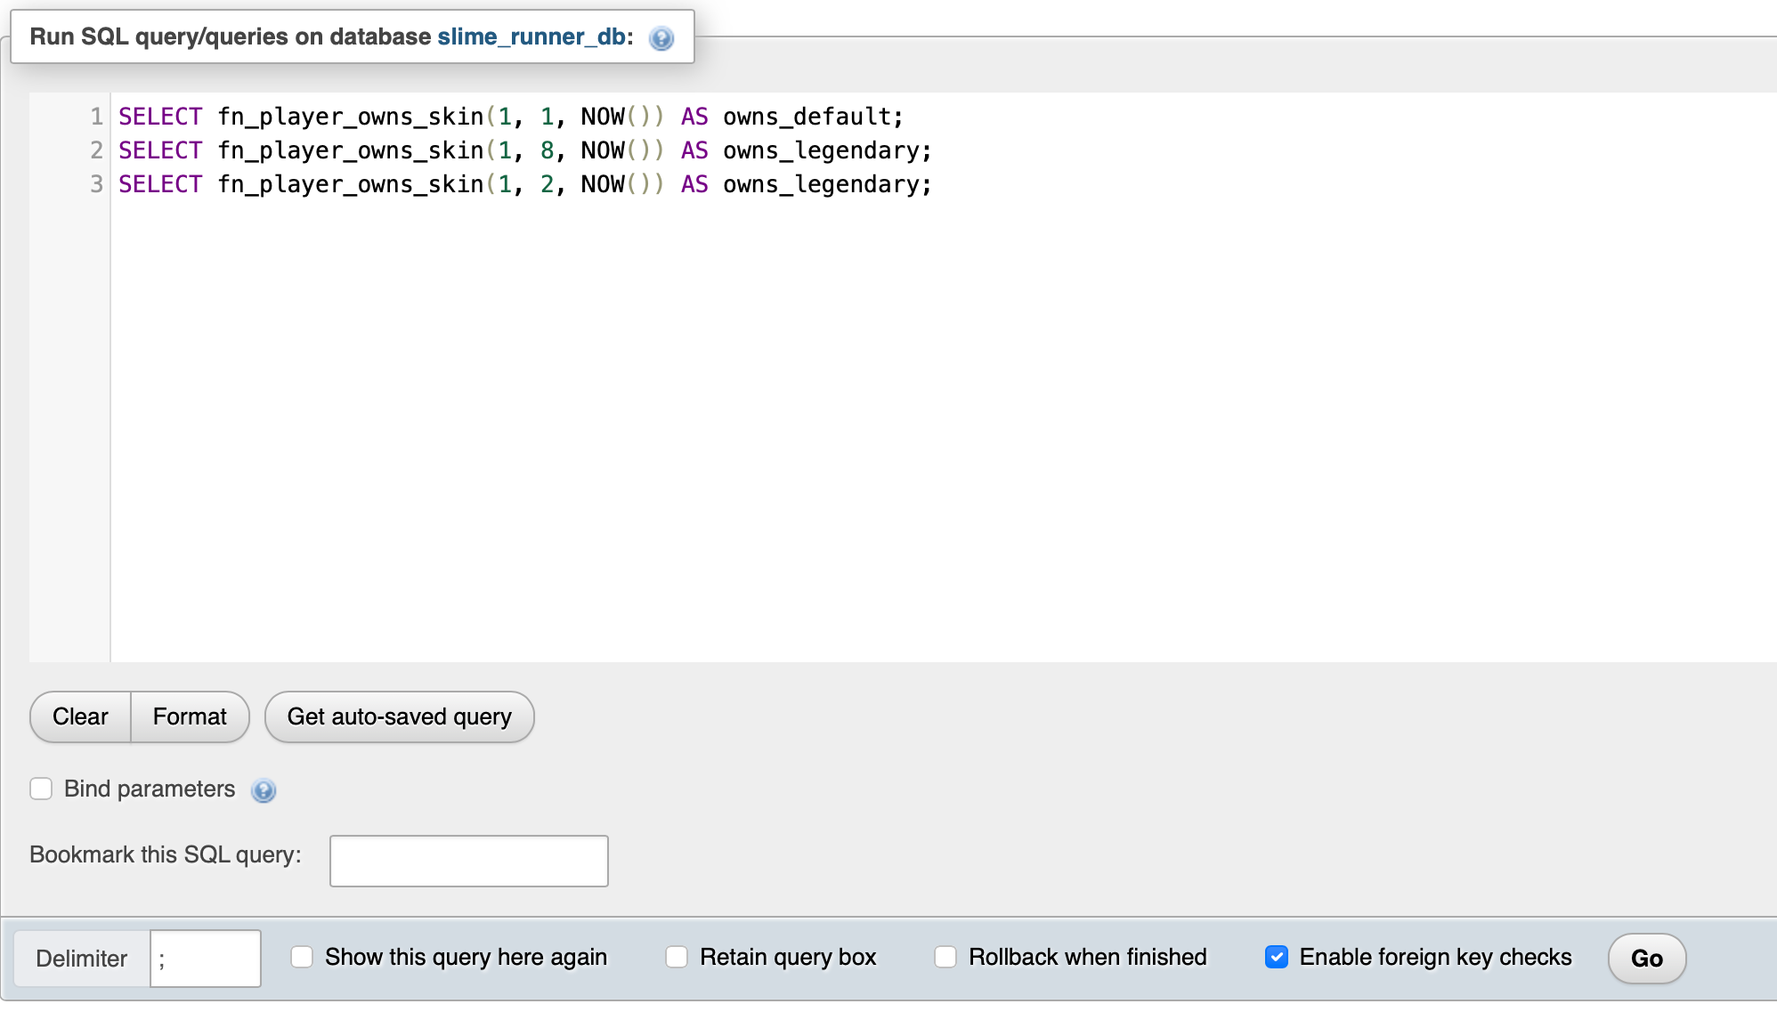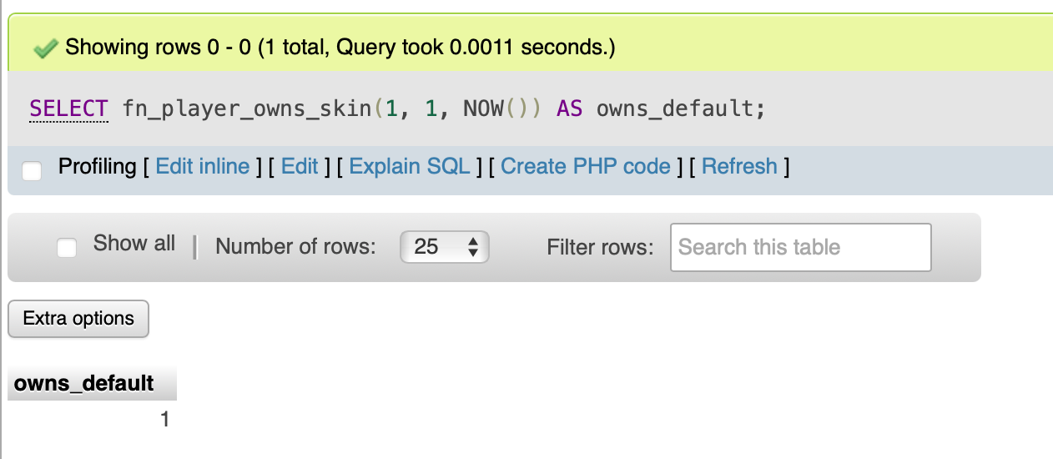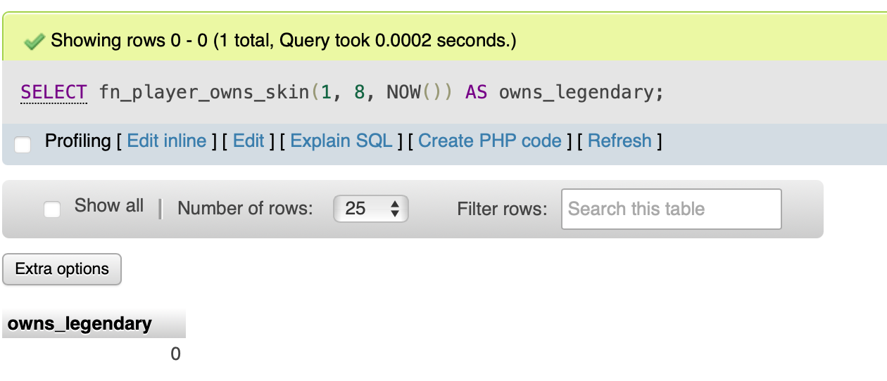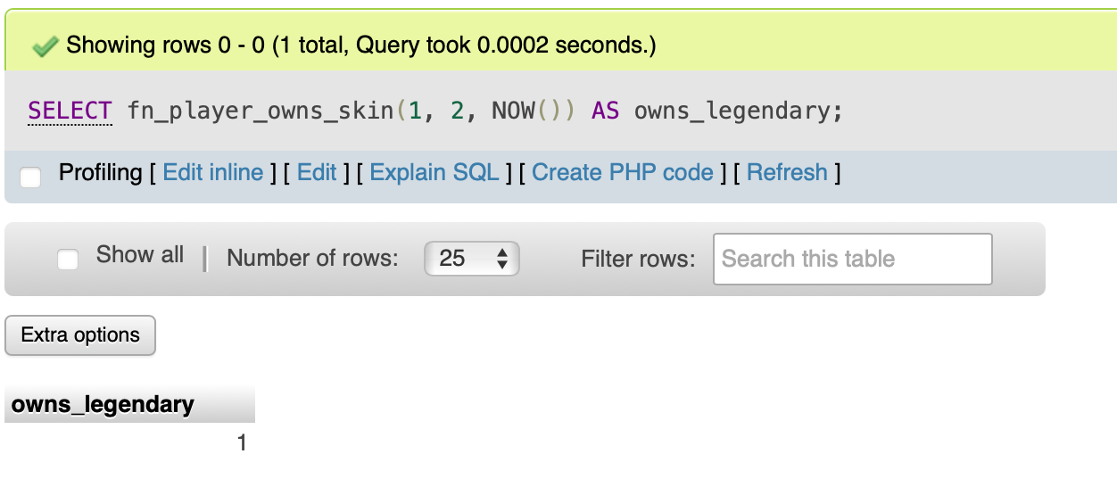

All tests passed successfully confirming the function works correctly.

**4. Conclusion**

We have successfully set up our MySQL database with all 10 required tables and populated them with realistic data. All tables contain at least 10 rows of practical data demonstrating our game functionality. We have implemented comprehensive SQL commands including CREATE, INSERT, SELECT, UPDATE, and DELETE operations. We implemented two different advanced SQL features: a stored procedure and a function (we also use CHECK constraints for integrity).